**Task Management System - API Documentation**

Table of Contents

Credential Module 2

POST Request: 2

PUT Request: 3

Project Module: 4

GET Request: 4

POST Request: 5

Task Status 8

GET Request 8

POST Request 8

User Module 9

POST Request 9

GET Request 10

# Credential Module

## POST Request:

Purpose: Check whether the entered credentials is valid

Sample Request:

<http://localhost:8080/Task_Management/credential>

Success Response:

{

    "credential": {

        "employee": {

            "id": 1

        }

    }

}

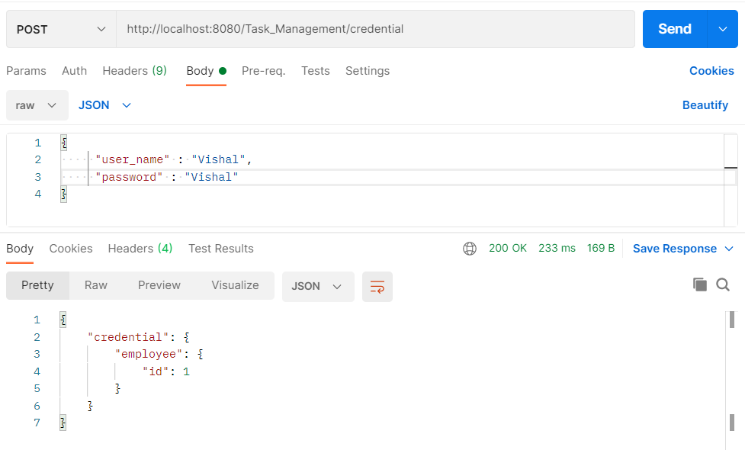

Failure Response:

{

    "credential": {

        "Message": "Check Your UserName!"

    }

}

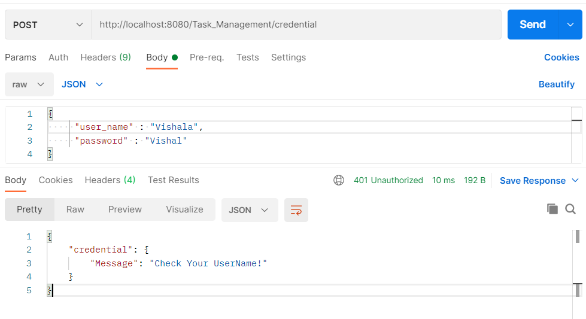

## PUT Request:

Purpose: Insert and Update Credentials

Sample Request:

<http://localhost:8080/Task_Management/credential>

Success Response:

{

    "credential": {

        "Message": "Credentials Created Successfully!"

    }

}

Failure Response:

{

    "credential": {

        "Message": "Cannot Create Credentials!"

    }

}

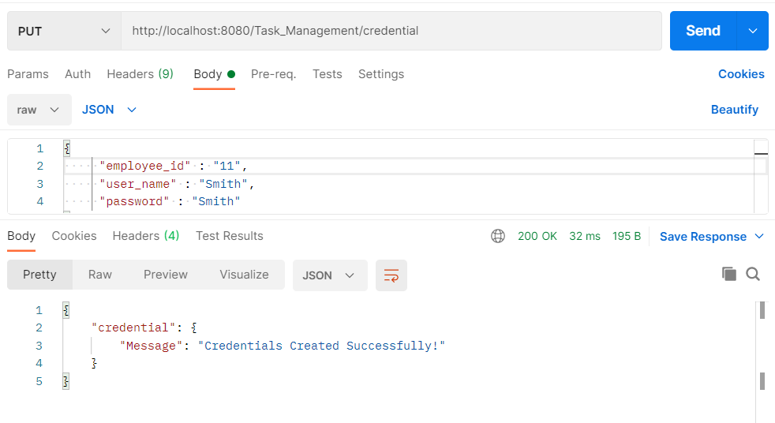

# Project Module:

## GET Request:

Purpose: Get all the project details from Database

Sample Request:

<http://localhost:8080/Task_Management/project>

Response:

{

    "projects": [

        {

            "is_completed": **false**,

            "project_id": 1,

            "project_name": "Employee Management System"

        },

        {

            "is_completed": **false**,

            "project_id": 2,

            "project_name": "Hospital Management System"

        },

        {

            "is_completed": **false**,

            "project_id": 3,

            "project_name": "Ticket Management System"

        }

    ]

}

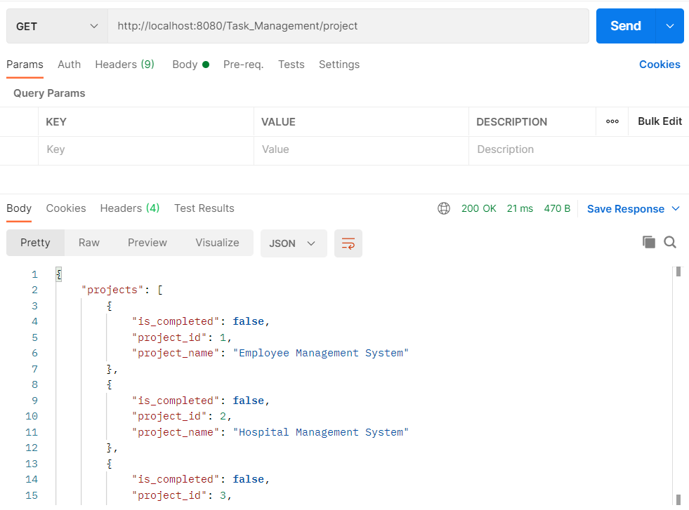

## POST Request:

Purpose: Create new project into Database

Sample Request:

<http://localhost:8080/Task_Management/project>

Success Response:

{

    "projects": [

        "Project Created Successfully!"

    ]

}

Failure Response:

{

    "projects": [

        "Cannot Create Project!"

    ]

}

**GET Request**

Purpose: Get the Task details of specified project id from Database

Sample Request:

<http://localhost:8080/Task_Management/project/1/>

Response:

{

    "projects": [

        {

            "is_completed": **false**,

            "project_id": 1,

            "project_name": "Employee Management System"

        },

        {

            "taskList": [

                {

                    "current_task_status": "Backlog",

                    "is_completed": **false**,

                    "task_id": 1,

                    "task_name": "Front End"

                },

                {

                    "current_task_status": "InProgress",

                    "is_completed": **false**,

                    "task_id": 2,

                    "task_name": "Back End"

                },

                {

                    "current_task_status": "InReview",

                    "is_completed": **false**,

                    "task_id": 3,

                    "task_name": "Middle Ware"

                },

                {

                    "current_task_status": "InReview",

                    "is_completed": **false**,

                    "task_id": 7,

                    "task_name": "Back End"

                }

            ]

        }

    ]

}

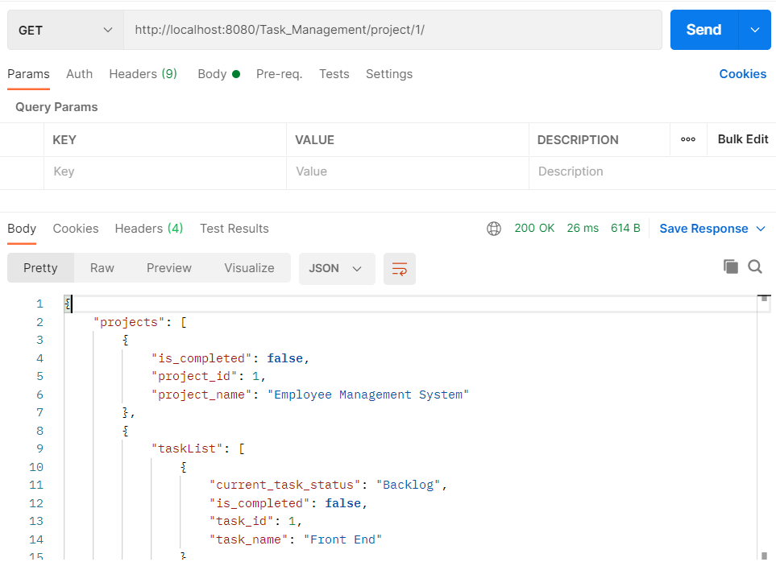

**POST Request**

Purpose: Insert Task details into Database

Sample Request:

<http://localhost:8080/Task_Management/project/>

Success Response:

{

    "response": {

        "Message": "Task Created Successfully!"

    }

}

Failure Response:

{

    "response": {

        "Message": "Cannot Create Task!"

    }

}

# Task Status

## GET Request

Purpose: Get all the Task Status from Database based on task id

Sample Request:

[http://localhost:8080/Task_Management/taskstatus/1/](http://localhost:8080/Task_Management/taskstatus/1/s)

Response:

{

    "taskStatus": {

        "taskStatusList": [

            {

                "end_date": "2021-06-16",

                "start_date": "2021-06-15",

                "task_status_id": 2,

                "task_type": "Backlog"

            }

        ]

    }

}

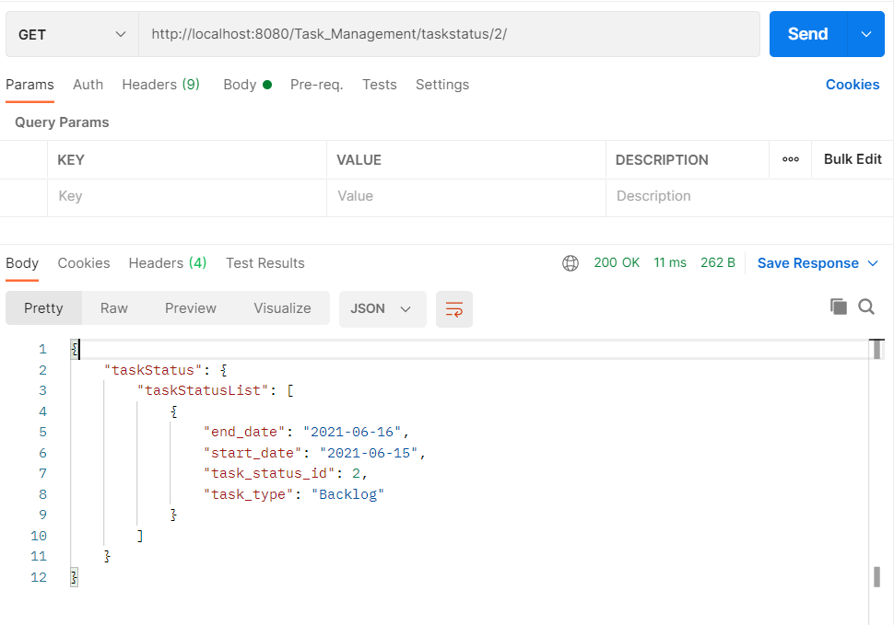

## POST Request

Purpose : Create a Task Status

Success Response

{

    "response": {

        "message": "Task Status Created Successfully!"

    }

}

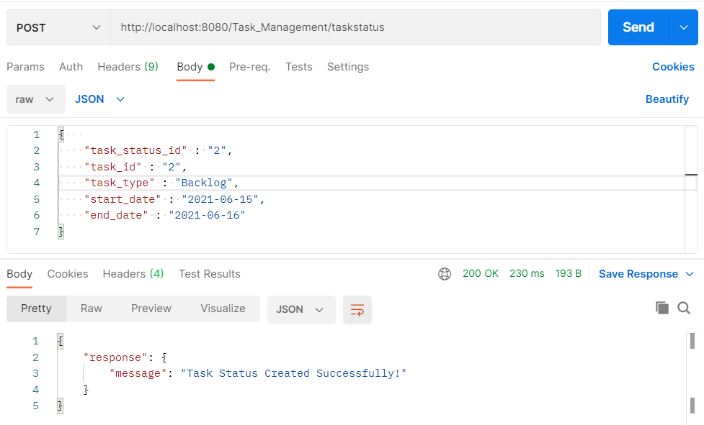

Failure Response:

{

    "response": {

        "message": "Task Status Creation Failed!"

    }

}

# User Module

## POST Request

Purpose: Creates new user in the database

Sample Request:

<http://localhost:8080/Task_Management/user>

Response:

{

    "response": {

        "message": "User Created Successfully!"

    }

}

## GET Request

Purpose: To fetch the user details based on their employee id.

Sample Request:

<http://localhost:8080/Task_Management/user/8/>

Response:

{

    "employee": {

        "employeedetails": [

            {

                "is_tl": **false**,

                "employee_email": "adam@gmail.com",

                "is_hr": **false**,

                "manager": {

                    "name": "Anirudh",

                    "id": "1"

                },

                "employee_id": 8,

                "employee_name": "Adam",

                "team_leader": {

                    "name": "Akash",

                    "id": "1"

                },

                "hr": {

                    "name": "Vishal",

                    "id": "1"

                },

                "is_manager": **false**

            }

        ]

    }

}

